**Hajee Mohammad Danesh Science and Technology University**

Department of Computer Science and Engineering (CSE)

Level-3 , Semester-I

Session -2020

Date of submission:

**Course Code :** CSE 305

**Course Title :** Software Engineering

**Assignment of S/W Project Proposal for SE**.

**Submitted By Submitted By**

Name : Mushfika Akther Pankaj Bhowmik

Student ID: 2002046 **Lecturer**,

**Project : Electricity Bill Payment System**

**Applied Software Development Life Cycle(SDLC):**

Iterative model is the suitable for the project of Electricity Bill Payment system.The Iterative model in software engineering involves repeating cycles of development, testing, and feedback. Here is a generalized outline of how you could implement the Iterative model for the development of an Electricity Bill Payment System.

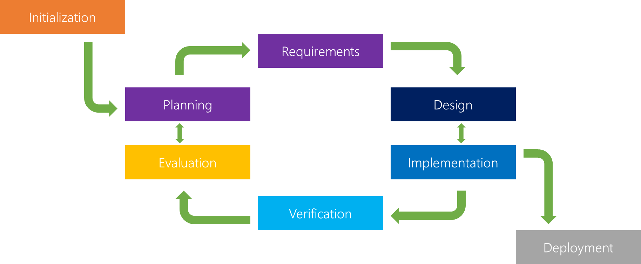

In the iterative model , an initial base software is created using the set of requirement. Then feature are constantly added to this base product in successive iterations until have a final product satisfying all requirements. We build and improve the product step by step.

**Identify Core Features**

Begin by identifying the essential features and functionalities required for the electricity bill payment system. These may include user registration, bill generation, payment processing , and account management.

**Create an initial design**

Develop an initial system design based on the identified features. This doesn’t have to be the final design,but it should provide a foundation for the first iteration .



Block diagram showing the proposed online Electricity billing system



**Flowchart of Activity Flow_Chart of the Administrator**



**Activity Flow_Chart of the Consumer**

**First iteration :**

Implementation a subset of the identified features in the first iteration.

This could involve developing the user registration and login functionality , as well as the basic bill generation and viewing capabilities.

**Testing and feedback:**

Conduct testing on the features implemented in the first iteration.

Gather feedback from users, stakeholders, and quality assurance teams.

**Refinement:**

Based on the feedback received , refine the system design and make necessary adjustments to the implemented features.

**Second iteration:**

Implement the refind features in the second iteration. This could involve extending the bill payment system to include additional features like multiple payment options, notifications, or enhanced security measures.

**Testing and Feedback:**

Repeat the testing process for the features implemented in the second iteration . Gather feedback and identify any issues or enhancements needed.

Development:

Deploy the final version of the Electricity Bill Payment System for any issues and address then promptly. Consider future iterations to add new features or make improvements based on user feedback and changing requirements.

Throughout this process, collaboration and communication between development teams , stakeholders, and end users are crucial .

The iterative model allows for flexibility and adaptatibility, making it well-suited for projects where requirements may envolve or change over time.